- Write the following a functional interface and implement it using lambda:
  - First number is greater than second number or not Parameter (int ,int ) Return boolean
  - Increment the number by 1 and return incremented value Parameter (int) Return int
  - Concatination of 2 string Parameter (String , String ) Return (String)
  - Convert a string to uppercase and return . Parameter (String) Return (String)

package java8;
@FunctionalInterface
interface interface1{
boolean fun1(int x,int y);
}
@FunctionalInterface
interface interface2{
int fun2(int x);
}
@FunctionalInterface
interface interface3{
String fun3(String x, String y);
}
@FunctionalInterface
interface interface4{
String fun4(String x);
}
public class q1 {
public static void main(String[] args) {
interface1 i1=(x,y)->{
return x>y;
};
boolean result= i1.fun1(4,2);
System.out.println(result);
interface2 i2=(x)->{
x=x+1;
return x;
};
System.out.println(i2.fun2(5));
interface3 i3=(x,y)->{
return x+y;
};
System.out.println(i3.fun3("hello","world"));
interface4 i4=(x)->{
x=x.toUpperCase();
return x;
};
System.out.println(i4.fun4("hello"));
}
}

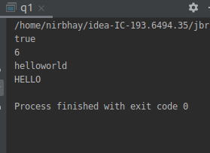

- Create a functional interface whose method takes 2 integers and return one integer.
package java8;
@FunctionalInterface
interface inter2{
int f(int x, int y);
}
public class q2 {
public static void main(String[] args) {
inter2 obj=(x,y)->{
return x;
};
System.out.println(obj.f(2,3));
}
}

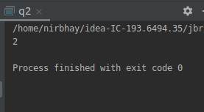

- Using (instance) Method reference create and apply add and subtract method and using (Static) Method reference create and apply multiplication method for the functional interface created.
package java8;
@FunctionalInterface
interface inter31{
int add1(int x,int y);
}
@FunctionalInterface
interface inter32{
int sub1(int x,int y);
}
@FunctionalInterface
interface inter3{
int mul(int x,int y);
}
public class q3 {
int add(int x,int y)
{
return x+y;
}
int sub(int x,int y)
{
return x-y;
}
static int mult(int x,int y)
{
return x*y;
}
public static void main(String[] args) {
inter3 i3=q3::mult;
System.out.println("multiplication-" + i3.mul(2,3));
inter31 i31=new q3()::add;
System.out.println("addition-" + i31.add1(10,15));
inter32 i32=new q3()::sub;
System.out.println("subtraction-" + i32.sub1(20,5));
}
}
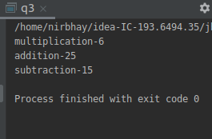

- Create an Employee Class with instance variables (String) name, (Integer)age, (String)city and get the instance of the Class using constructor reference

package java8;
interface emp1{
emp get_details(String name, int age, String city);
}
class emp
{
String name;
int age;
String city;
emp(String name, int age, String city)
{
this.name=name;
this.age=age;
this.city=city;
}
void disp()
{
System.out.println("name= "+name);
System.out.println("age= "+age);
System.out.println("city= "+city);
}
}
public class q4 {
public static void main(String[] args) {
emp1 obj=emp::new;
emp o1=obj.get_details("nirbhay",20,"delhi");
o1.disp();
}
}
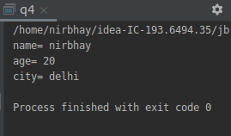

- Implement following functional interfaces from java.util.function using lambdas:
(1) Consumer
(2) Supplier
(3) Predicate
(4) Function

package java8;
import java.util.function.Consumer;
import java.util.function.Function;
import java.util.function.Predicate;
import java.util.function.Supplier;
public class q5 {
public static void main(String[] args) {
Consumer<Integer> consumer=(e)-> System.out.println(e) ;
consumer.accept(10);
Supplier<Integer> supplier=()-> 6;
System.out.println(supplier.get());
Function<Integer,Integer> function=(e)-> e+4;
System.out.println(function.apply(4));
Predicate <Integer>predicate=(e)-> e>2;
System.out.println(predicate.test(3));
}
}

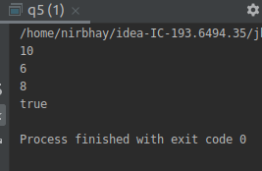

- Create and access default and static method of an interface.
package java8;
interface def{
default void disp()
{
System.out.println("default method");
}
static void show()
{
System.out.println("static method");
}
}
public class q6 implements def{
public static void main(String[] args) {
q6 obj=new q6();
obj.disp();
def.show();

}
}
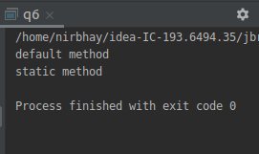

- Override the default method of the interface.

package java8;
interface interfc1{
default void show(){
System.out.println("interface 1");
}
}
interface interfc2{
default void show(){
System.out.println("interface 2");
}
}
public class q7 implements interfc1,interfc2{
@Override
public void show(){
interfc1.super.show();
interfc2.super.show();
}
public static void main(String[] args) {
q7 obj=new q7();
obj.show();
}
}

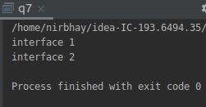

- Implement multiple inheritance with default method inside interface.
package java8;
interface interf1{
default void show1(){
System.out.println("interface 1");
}
}
interface interf2{
default void show2(){
System.out.println("interface 2");
}
}
public class q8 implements interf1,interf2{
public static void main(String[] args) {
q8 obj=new q8();
obj.show1();
obj.show2();
}
}
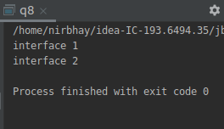

- Collect all the even numbers from an integer list.
package java8;
import java.util.Arrays;
public class q9 {
public static void main(String[] args) {
Arrays.asList(1,2,3,4,5,6,7,8)
.stream()
.filter(e->e%2==0)
.forEach(System.out::println);
}
}
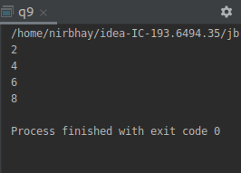

- Sum all the numbers greater than 5 in the integer list.
package java8;
import java.util.Arrays;
import java.util.List;
import java.util.stream.Collectors;
public class q10 {
public static void main(String[] args) {
List<Integer> ls= Arrays.asList(1,2,3,4,5,6,7,8,9,10);
System.out.println(
ls
.stream()
.filter(e->e>5)
.collect(Collectors.summingInt(e->e))
);
}
}

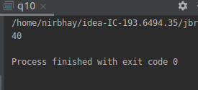

- Find average of the number inside integer list after doubling it.
package java8;
import java.util.Arrays;
public class q11 {
public static void main(String[] args) {
System.out.println(
Arrays.asList(1,2,3,4,5)
.stream()
.mapToDouble(e->e)
.average()
);
}
}

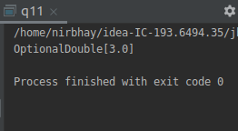

- Find the first even number in the integer list which is greater than 3.

package java8;
import java.util.Arrays;
import java.util.List;
import java.util.Optional;
public class q12 {
public static void main(String[] args) {
List<Integer> ls= Arrays.asList(1,3,5,6,7,8,10);
Optional<Integer> o=ls
.stream()
.filter(e->e%2==0)
.filter(e->e>3)
.findFirst();
if(o.isPresent())
System.out.println(o.get());
else
System.out.println("k");
}
}
